GoodReviews Case Study

Product Basics
GoodReviews is an omnichannel review collection and reputation management platform designed to help businesses showcase authentic feedback. Its website (https://goodreviews.co) touts an “Omnichannel Review Platform” for boosting customer confidence by highlighting positive user feedback【1†L50-L53】. The platform addresses the challenge that “managing reviews can be time-consuming for business owners,” enabling users to streamline review collection. For example, GoodReviews lets businesses send personalized review requests to hundreds of customers at once and share links to all their review channels in just a few clicks【1†L89-L93】. This solves common problems such as difficulty gathering new reviews, low overall ratings, and managing reviews across multiple sites. By automating review invites and aggregating feedback, GoodReviews helps businesses boost ratings and increase review volume【1†L89-L93】.
- What is GoodReviews? An online, omni-channel review collection and reputation management platform【1†L50-L53】.
- Website URL: https://goodreviews.co
- Problems addressed: Time-consuming review management; low review counts/ratings; scattered reviews across platforms【1†L89-L93】.

Your Role (UI/UX Design)
In a UI/UX case study for GoodReviews, the designer’s role would include: UX research to understand user needs, mapping user flows for review collection and management, creating wireframes and interactive prototypes, and designing a cohesive visual interface (including a design system) for the platform. This would involve iterating on layouts for dashboards, campaign creation flows, analytics screens, etc., to ensure a smooth user experience. Collaboration with product and engineering teams would ensure features align with business goals.

Screens & Modules
Based on the site content, the GoodReviews platform likely comprises the following modules/screens:
- Dashboard (Overview): A central dashboard showing aggregate review statistics and quick actions.
- Review Management: A Reputation Management dashboard where users can monitor, read, and respond to reviews from multiple sites in one place【4†L68-L72】.
- Campaign/Campaigns: Interface to create and manage multi-step review campaigns (email/SMS invites, reminders)【27†L1-L4】.
- Invitations (Email/SMS Requests): Sending personalized review requests via email or SMS, automating post-purchase follow-ups【14†L253-L256】.
- Alerts/Notifications: Real-time alerts for new reviews, so businesses can respond quickly【4†L76-L79】.
- Analytics / Reporting: An Analytics Dashboard with review trends, sentiment analysis, and ratings summaries【4†L83-L86】【14†L264-L268】.
- Review Widgets: Tools to generate embeddable review widgets for a website (listed under pricing features)【27†L1-L4】.
- Social Media Reviews: A section for managing and sharing reviews on social platforms (Facebook, Instagram, etc.).
- Settings: Business profile settings, user/team management, and account/subscription plans.
- Google Business Profile Setup: Setup or integration screens for managing the company’s Google Business Profile (a key capability)【3†L53-L60】.
Each of these modules would have corresponding UI screens: e.g. login/signup screens, campaign creation form, dashboard with charts, settings pages, etc., consistent with the branding.

User Types
While the site doesn’t list roles explicitly, the platform is intended for business users, so likely user types include:
- Business Owner / Manager: Primary users who create campaigns and monitor reputation.
- Marketing Manager: Plans review campaigns and analyzes analytics.
- Branch or Location Manager: Manages reviews for a specific branch (if multi-location).
- Admin/Super Admin: Oversees account-wide settings, user permissions, and subscription details.
- Agency Partner: Marketing agencies managing multiple client accounts.
- End Customer: The customer receiving review requests and leaving feedback (not an app user, but part of workflow).
(Note: GoodReviews itself has no direct reference to these roles on the site, but such roles are typical for this type of SaaS.)

Main Workflow
An ideal user workflow on GoodReviews would flow as follows:
- Business Signup/Onboarding: The business registers for an account (e.g. starts a free trial). They set up their business profile, possibly including integration with their Google Business Profile【3†L53-L60】.
- Create Review Campaign: The user creates a campaign, selecting channels (Email/SMS) and templates. GoodReviews automates review requests – for example, after a customer purchase it can send an email or SMS asking for a review【14†L253-L256】.
- Customer Leaves Review: Customers receive the invite (or scan a QR code, if provided) and leave a review on Google, Facebook, Yelp, or other linked platforms.
- Review Monitoring: New reviews from these channels are collected and displayed in real time on the GoodReviews dashboard【14†L248-L251】. The system triggers alerts/notifications for new reviews, allowing the business to respond promptly【4†L76-L79】.
- Analytics: All review data feeds into an analytics module. The platform uses AI-driven sentiment analysis to gauge customer satisfaction【14†L258-L262】. A reporting dashboard shows trends in ratings and review volume【4†L83-L86】【14†L264-L268】.
- Optimization: The business iterates on campaigns based on analytics (e.g. sending more invites via the most effective channels). They use omnichannel collection tools to maintain high review counts and ratings across all connected platforms【14†L242-L247】.
Each step would be supported by specific UI screens (signup page, campaign builder, monitoring dashboard, analytics view, settings, etc.), ensuring a smooth flow from invitation to insight.

Features
GoodReviews offers a comprehensive set of features, including (with site references):
- Omni-Channel Review Collection: Collect reviews seamlessly across Google, Yelp, Facebook, TripAdvisor, Trustpilot, and more【14†L242-L247】【1†L139-L142】. Businesses can link all major review sites and even embed widgets on their own website.
- Automated Review Requests: Email and SMS invitations can be automated post-purchase to solicit customer reviews【14†L253-L256】. The system can send personalized follow-ups to boost response rates.
- Multi-Step Review Campaigns: Users can create multi-step campaigns (e.g. reminder sequences) to maximize reviews【27†L1-L4】.
- Review Widgets: Widgets to display aggregated reviews or ratings on the business’s website【27†L1-L4】.
- Real-Time Review Monitoring: Incoming reviews are monitored in real time, enabling prompt responses【14†L248-L251】.
- Alerts & Notifications: Instant alerts notify the business of new reviews, helping address negative feedback quickly【4†L76-L79】.
- Analytics Dashboard: A comprehensive reporting dashboard shows review trends, ratings over time, and key metrics【14†L264-L268】.
- Sentiment Analysis: AI-powered analysis automatically gauges sentiment and highlights common keywords from reviews【14†L258-L262】. Businesses can see at a glance how customers feel.
- Social Media Reviews: Features to share positive reviews on social media (e.g. Facebook, Instagram) for increased visibility.
- Google Business Profile Management: Tools or guidance for setting up and optimizing the Google Business Profile to improve local search visibility【3†L53-L60】.
- Review Response Tools: (Implied) The ability to respond to reviews directly within the dashboard for reputation management.
Many of these features are highlighted under the Pricing/Features section【14†L242-L247】【14†L253-L256】 and on the site’s capability pages (e.g. GoodReviews Local)【4†L68-L72】【4†L83-L86】.

Screenshots
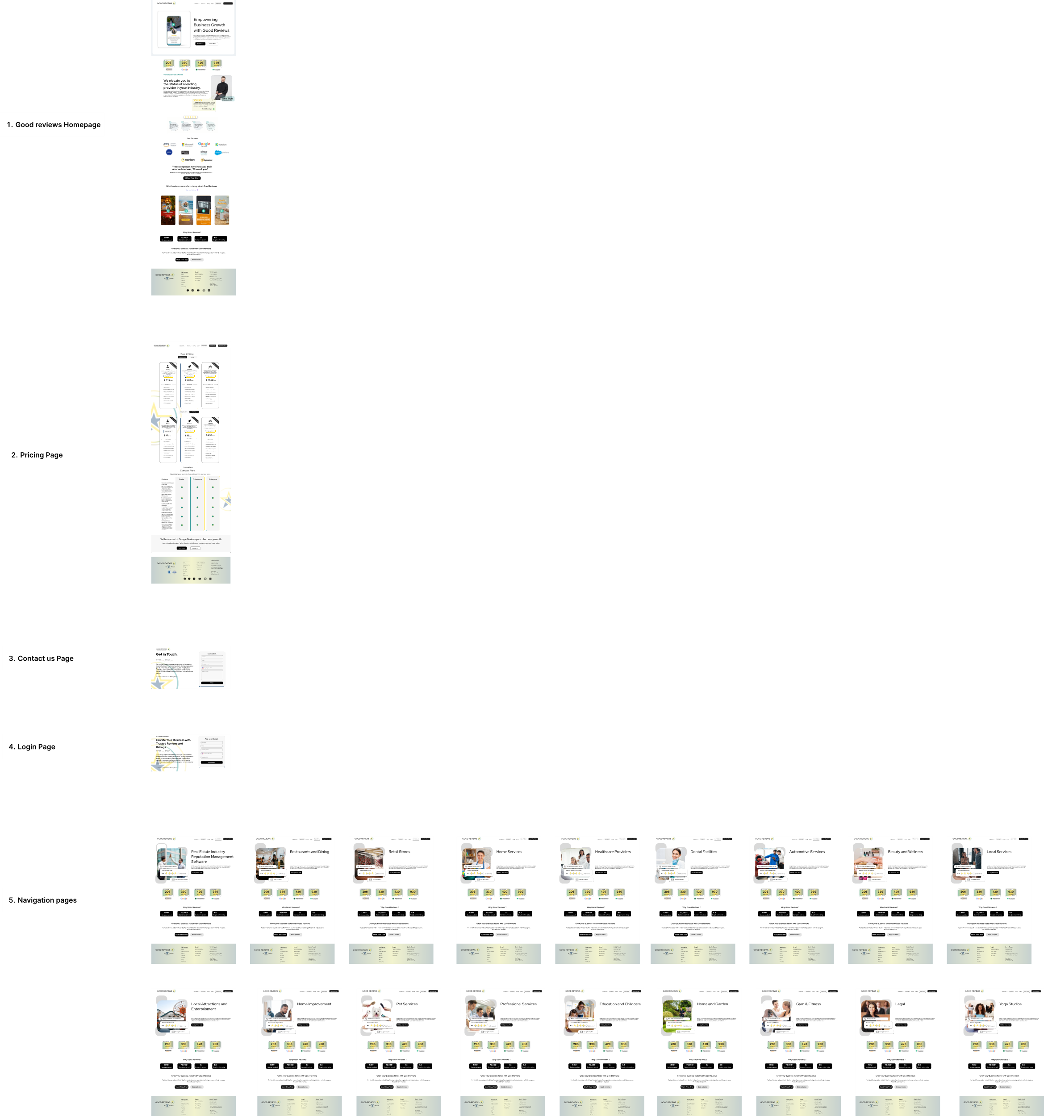

Business Metrics
According to GoodReviews’ marketing site, the platform has achieved the following results for users (as cited on multiple industry pages):
- Reviews Enabled: ~1.9 million customer reviews collected through the platform【8†L78-L86】.
- Businesses Served: ~70,000 business locations or users have used GoodReviews【8†L78-L86】.
- Review Growth: Clients have seen about a 5× increase in their review volume after using the tool【8†L90-L94】.
- Average Rating: GoodReviews-assisted businesses boast an average Google rating of 4.8/5【8†L96-L100】.

Integrations
GoodReviews connects with a wide range of review platforms and channels. Per the site, it collects reviews from Google, Yelp, Facebook, TripAdvisor, GoodFirms, Trustpilot, Zocdoc, Angi’s List, BBB, Glassdoor, DesignRush, and websites via embedded widgets【1†L139-L142】. It also supports social media integration for sharing reviews (e.g. pulling Facebook reviews). On the communications side, it integrates with email and SMS systems to send review requests (as implied by the automated request feature). (No mention of payment or third-party automation integrations like Stripe or Zapier was found on the site.)

AI Features
GoodReviews leverages AI primarily for sentiment analysis. The platform uses AI-driven text analysis to gauge customer emotions and extract insights from reviews【14†L258-L262】. This helps businesses understand overall satisfaction and highlight areas for improvement. Aside from sentiment analysis, no other AI features (e.g. AI reply generation or review summarization) were mentioned on the site.

Case Study Positioning
This case study focuses on GoodReviews as a Reputation Management and Review Collection solution, emphasizing its UI/UX features and workflow. In a portfolio context, it would showcase how the design of GoodReviews’ interface helps streamline tasks like sending review requests, monitoring feedback, and analyzing results. The goal is to highlight design decisions that make review management easy and effective for businesses, aligning with GoodReviews’ value proposition of “Boost[ing] Business Growth with Customer Feedback & Social Proof”【1†L46-L53】.
Sources: All information above is based on GoodReviews’ official website【1†L46-L53】【4†L68-L72】【8†L78-L86】【14†L242-L247】, including product pages and pricing details. The cited excerpts correspond to the sections indicated.

